Título en español e inglés, escrito en formato oración, con un máximo de 15 palabras. Con letra Times New Roman de 14 puntos, en negrita y centrado.

Spanish and English Title, written in sentence format, with a maximum of 15 words. With Times New Roman font of 14 points, bold and centered.

Full name and surname of the first author,
Full name of the institution or organization that appears as institutional filiation
City, Country,
Email@author
ORCID number: https://orcid.org/XXXXXXXXXXXX

Full name and surname of the second author,
Full name of the institution or organization that appears as institutional filiation
City, Country,
Email@author
ORCID number: https://orcid.org/XXXXXXXXXXXX

Resumen:

Se redacta en un solo párrafo, da cuenta del tema, el objetivo, los puntos centrales de la investigación y las conclusiones, no debe exceder las 150 palabras y se presenta español (Resumen) e inglés (Abstract). Letra Times New Roman de 12 puntos

Abstract:

It is written in a single paragraph. It gives an account of the subject, the objective, the central points of the study, and the conclusions. It should not exceed 150 words and should be presented in Spanish (resumen) and English (abstract). Times New Roman 12-point Font.

Palabras claves:

De cuatro a seis palabras o grupo de palabras, ordenadas alfabéticamente, la primera con mayúscula inicial, el resto en minúsculas, separadas por punto y coma (;) y que no se encuentren en el título o subtítulo. Deben presentarse español e inglés, estas sirven para clasificar temáticamente al artículo.

Keywords:

Four to six words or groups of words, sorted alphabetically, the first with an initial capital, the rest in lower case, separated by semicolons (;) and not in the title or subtitle. It must be presented in Spanish and English; they serve to classify the article thematically.

Table of contents. 1. Introduction 2. Development. 3. Conclusion.

Example:

Table of contents. 1. Introduction.2. Development. 2.1. Gradiva, by Victor Burgin. 2.1.1. Introduction to the composition of the series. 2.1.2. Correspondences and textual parallelisms. 2.1.3. Correspondences and visual parallelisms. 2.1.4. Underlying concepts in the creation of the Gradiva series. 3. Conclusions

Text Format

The body of the article is divided into at least: 1. Introduction; 2. Development with their respective sections 3. Conclusions and References Bibliography. The latter is not numbered.

The first level sections are included in bold (1. 2. 3.) while the second level sections are included in italics (1.1. 1.2. 1.3. ...). The latter will be used only when necessary. Only these two levels (1, 2, 3,...1.1. 1.2 1.3) may be used.

Pages should be numbered, with 1.5 line spacing and 12-point Times New Roman font. Articles should be between 4,000 and 8,000 words long (for articles), between 500 and 1,500 words long (for reviews), and between 2,000 and 5,000 words long (for interviews).

Citations
They should not exceed five lines or 40 words; otherwise, they should not be placed in a separate paragraph, and the font size should be 11.
The following form of citation within the text will be used: It will be in parentheses (author, year, page): "If the extreme separates what is literature and cinema from what is no longer so, its aesthetic does not consist in consummating the passage but rather failing to comply with it" (Oubiña, 2011, 30).
Likewise, the following alternatives can be used:
According to Oubiña: "If the extreme separates what is literature and cinema from what which is no longer is, its aesthetic functionality does not consist in consummating the passage, but rather, in unfulfilling it" (2011, 30).

According to Oubiña (2011): "If the extreme separates what is literature and cinema from what is no longer literature and cinema, its aesthetic functionality does not consist of consummating the passage but, rather, of failing to comply with it" (30).
If there are two authors, the citation in the body of the text will be in parentheses with the name of the two authors joined by the symbol "&." "We have adopted the hypotheses that advocate the radically dialogical nature of language (Bajtin, Benveniste) and those that find in the function of enunciation the foundation of discursive practices (Foucault)" (Abril, Lozano & Peña-Marín, 1982, 253).
Even in cases where a literal quotation is not included but a paraphrased idea, it must be included in parenthesis (author, year, page)
If it is a film, a piece of art, a photograph, or a painting, the first time cited will be indicated: Title (Director, year). For example: Qué tan lejos (Tania Hermida, 2006).

Footnotes
The use of footnotes is not recommended, only in specific cases.

Style
Bold type should be used only for the title, author's name, and first section. Italics should be used for names of books, movies, foreign words, and second-level sections. Underlining should not be used in any case.

Figures and Tables
Ensure that all illustrations are clear and legible. Figures and tables should be inserted in appropriate places throughout the body text. Figures and tables should be identified in the body text. Do not group them at the beginning or end of the document. Both figures and tables, as shown in the examples (see Table 1 and Figure 1), should be numbered sequentially. In contrast, the title pertaining to a figure should always appear below the illustration. A table title should always be placed above the illustration. When referring to a series of images presented together in sequence, the numbering starts with a hyphen before the final numbering (see Figure 2-4). Figures and Tables always include their numbering in bold, caption, author and year in parentheses, source, and, if applicable, web link—for example, Figure 1. Adam and Eve deconstructed. Diet (Óscar Santillán 2009). Source: Archivo Nuevos Medios Ecuador. http://archivo.aanmecuador.com/

Table 1. Table subtitles should always be placed above the illustration. (Author, Year). Source: XXX

 | Column 1 | Column 2 | Column 3
Row 1
Row 2
Row 3
Row 4

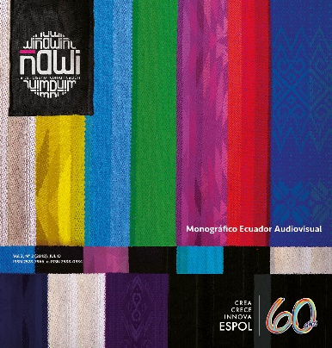

Figure 1. The legend pertaining to a figure must always appear below the illustration (Author, Year). Source: XXX

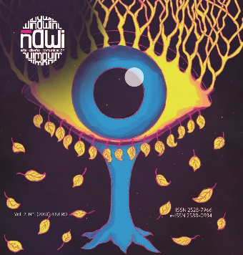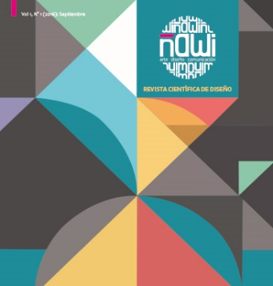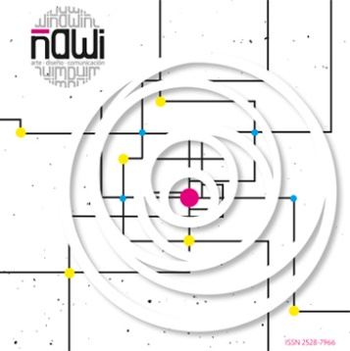
Figures 2-4. If there is a sequence, a dash is added.

If the author incorporates images, they must provide the corresponding authorization. Otherwise, they must comply with article 32 of the TRLPI, which states the inclusion of photographic, plastic, or figurative works of others does not require the authorization of the author, provided that the following conditions are met:
- that what is included corresponds to a work already published,
- that it is done for research purposes,
- that it responds to the "right of citation" for analysis, commentary, or critical judgment.
- The source and the name of the author of the work used are indicated.
Graphics, images, and figures should be of sufficient quality for digital reproduction, and the original graphic files (if the article is accepted) should be attached in a separate file (preferably in JPG or PNG format). It is important to indicate the place where they will appear in the body of the text as follows: FIGURE 1 THIS WAY.

The author is responsible for acquiring the rights and/or authorization to reproduce images and/or graphics taken from other sources, refereeing regulations, and external evaluation of the work.

Bibliographical References
Bibliographical References are written on a new page in bold type at the end of the article's conclusion. They should be ordered alphabetically.

For bibliographical references, paragraph format with French indentation (Hanging) is used.

Example:
Panero Gómez, A. (2013). Análisis iconológico de la figura de Gradiva. Construcciones del personaje en la cultura plástica y audiovisual contemporánea. Tesis Doctoral bajo la dirección de Pilar Aumente Rivas. Madrid: Universidad Complutense de Madrid. Facultad de Ciencias de la Información.

[Panero Gómez, A. (2013).Iconological analysis of the figure of Gradiva. Construction of the character in contemporary and audiovisual culture. Doctoral thesis under the direction of Pilar Aumente Rivas. Madrid: Complutense University of Madrid. Faculty of Information Sciences.]

The rules of the APA system 7th edition 2019 with adaptations will be followed:
http://www.apastyle.org/
Journal article. Surname, Initials of the author's name. (Year). Title of the journal. Name of the journal with capital letters in each noun word and italics, volume (number), pages. DOI with https://doi.org.
Example:
Larrañaga, J. (2016). La nueva condición transitiva de la imagen. Barcelona, Research Art Creation, 4 (2), 121-136. http://dx.doi.org/10.17583/brac.2016.1813
[Larrañaga, J. (2016). The new transitive condition of the image. Barcelona, Research Art Creation, 4 (2), 121-136. http://dx.doi.org/10.17583/brac.2016.1813]
If the journal has the format where only the issue is included:
Example:
Barriendos, J. (2011). La colonialidad del ver. Hacia un nuevo diálogo visual interepistémico. Nómadas, 35, 13-29. http://dx.doi.org/10.17583/brac.2016.1813
[Barriendos, J. (2011). The coloniality of seeing. Towards a new interepistemic visual dialogue. Nómadas, 35, 13-29. http://dx.doi.org/10.17583/brac.2016.1813]
Press article. Surname, Initials of the author's name. (Day. Month. Year). Title of the new item. Name of the newspaper in italics. Web link.
Example:
Abril, G. (13 de noviembre, 2013). De la cultura como déjà vu. Diagonal.https://www.diagonalperiodico.net/blogs/gonzalo-abril/la-cultura-como-deja-vu.html
[Abril, G. (November 13, 2013). Of culture as déjà vu. Diagonal.https://www.diagonalperiodico.net/blogs/gonzalo-abril/la-cultura-como-deja-vu.html]
Book. Surname, Initials of the author's name (Year). Title of the book in italics. City: Publisher.
Example:
Oubiña, D. (2011). El silencio y sus bordes: modos de lo extremo en la literatura y el cine. México: Fondo de Cultura Económica.
[Oubiña, D. (2011). Silence and its edges: Modes of the Extreme in Literature and Cinema. Mexico: Fondo de Cultura Económica.]
If there are two authors, they are coordinated with the symbol "&":
Abril, G., Lozano, J., & Peña-Marín, C. (1982). Análisis del Discurso. Hacia una semiótica de la interacción textual. Madrid: Cátedra.
[Abril, G., Lozano, J., & Peña-Marín, C. (1982). Discourse Analysis. Towards a semiotics of textual interaction. Madrid: Cátedra.]
Book chapter. Surnames, Initials of the author. (Year). Title of the chapter. In initials of the last name and surname (Ed.). Title of the book (pp. pages). City: Publisher.
Example:
Catalá, J. (2012). Formas de la distancia: los ensayos fílmicos de Llorenç Soler. En M. Francés (Ed.). La mirada comprometida (pp. 97-115). Madrid: Biblioteca Nueva.
[Catalá, J. (2012). Forms of distance: the filmic essays of Llorenç Soler. In M. Francés (Ed.). La mirada comprometida (pp. 97-115). Madrid: Biblioteca Nueva.]
Images. Films, documentaries, television programs, series, video art pieces, photographs, paintings, designs, advertising. Name of the work (Name and Surname of the author, year).
Example:
Qué tan lejos (Tania Hermida, 2006)
Blog entry. Surname, Initials of the author's name. (Day, Month, Year). Title of the blog entry. Name of the blog in italics. Web link.
Example:
García López, R. (July 20, 2020). Llega un tren. Marginalia. https://marginaliafragmentos.blogspot.com/2020/07/llega-un-tren.html
[García López, R. (July 20, 2020). A train arrives]. Marginalia. https://marginaliafragmentos.blogspot.com/2020/07/llega-un-tren.html]
Web page. Name of the institution or author of the website (Ed.) (Year). Title of the information or web consulted. Web link.
Example:
Fem Tour Truck (Ed.). (2020). Festival itinerante de cine feminista. http://www.femtourtruck.com/home/festival/
[Fem Tour Truck (Ed.). (2020). Traveling feminist film festival. http://www.femtourtruck.com/home/festival/]

For all other references (dictionary entries, Wikipedia entries, government agency reports, code of ethics, conferences, doctoral dissertations, unpublished master's theses, and/or social networks), consult APA 7th edition 2019.
This journal provides immediate open access to its content that seeks to make research freely available to the public and supports a greater global knowledge exchange.
For clarifications on conflicts of interest, plagiarism, and other ethical issues, review the Ethics and Best Practices section.

Curricular Review
Include a brief curriculum vitae of no more than 100 words.

Declarations
In case of more than one author, following the authorship criteria CRedit taxonomy (https://credit.niso.org/), please declare the author's individual contributions. Failure to declare individual contributions will imply equal participation of all the authors.

Depending on the case, authors must include one of the following statements on the use of AI:
Case 1. No use of AI
“The author(s) declare(s) that no artificial intelligence tools have been used for the preparation of this article”.
Case 2. Use of AI
“The author(s) declare(s) that, in the preparation of this article, AI tools (specify the name of the AI and its version) were used………… for the purpose of ……….(specify which tasks were performed with the support of AI and in which sections of the article).”

